**cid:image001.png@01CE4723.23966790**

Mahindra World City (Jaipur) Limited, 411, Neelkanth Towers, 1,

Bhawani Singh Marg, C-Scheme, Jaipur- – 302001

Tel: +91 141 6683454, Fax: +91 141 2243060

Email : Jaipurtenders@mahindraworldcity.com

**May 2022**

**RFP/INFRA/DTA/CONSULTANCY/2022-23/01**

**REQUEST FOR PROPOSAL**

**FOR**

**Master Planning for Domestic Tariff Area - DTA (200 Acres) in Mahindra World City, Jaipur**

**Annexure 1: Draft Brief to the Master Planner for preparation of Master Plan for an extent**

**of about 200 acres for the proposed Industrial Park in Mahindra World City Social Infra area.**

**1. Design brief of the Project:**

Project Scope & Understanding

Mahindra World City Jaipur is a planned integrated SEZ over ~2950acres development in collaboration with RIICO, a Government of Rajasthan agency. This development comprises of industrial, residential and mixed used complexes, strategically located on the outskirts of Jaipur. The CLIENT has pioneered the concept of integrated business city with approximately 30,000 direct and indirect employees working within it currently. The current master plan has 1500 acres of SEZ Processing area, 1000 acres of Domestic Tariff Area (DTA Phase I & II) and Social Infrastructure which is spread over ~453 acres of land and is located 22kms from the airport and 21kms from City Centre and Railway Station.

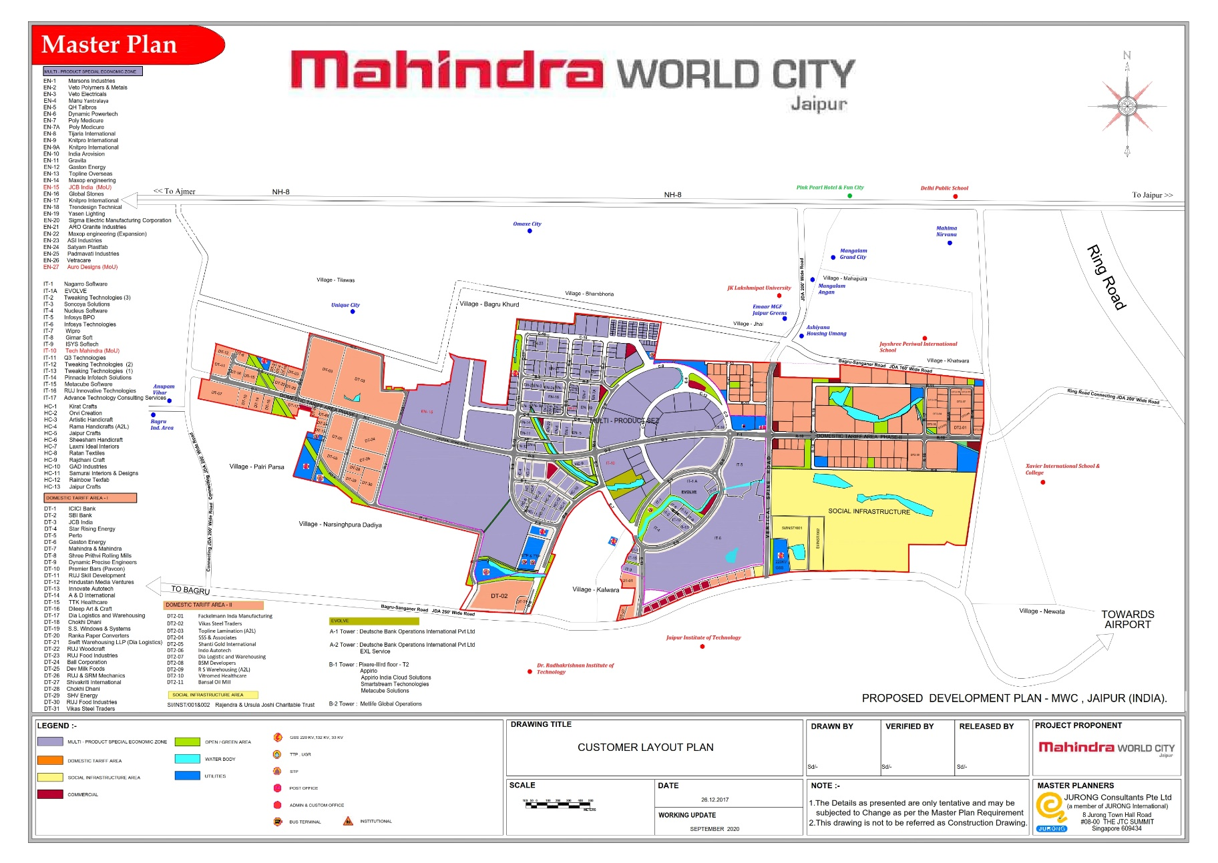

**SITE**

**200 acres**

**2. The proposed Master Plan should address the following:**

1. To develop a conceptual layout plan for the proposed park for a total extent of about 200 acres considering all relevant factors with regard to planning objectives, development opportunities and constraints.
2. To identify the extent of the park’s potential development and its relationship to the adjoining infrastructure, SEZ and DTA2 area.
3. To provide the planning and phasing of infrastructure development to optimize the land use with respect to existing infrastructure/ utilities allocated.
4. To illustrate overall layout and urban design guidelines for the park.
5. To prepare the overall master plan for the entire 200 acres as per our map indicating phases if relevant.
6. To produce written and illustrative materials to demonstrate the development to the client and the Government authorities in Rajasthan.

The master plan deals principally with the utilization of about 200 acres of land planned by Mahindra World City situated in Jaipur. The scope of work covers 2 main aspects:-

* The overall concept plan for the entire area of about 200 acres.
* The detailed Master Plan for the entire area of 200 acres in context with overall Master Plan of MWC Jaipur particularly DTA 2 area.

The Master Plan will provide the land-use, road and major infrastructure layout proposals for the entire site area. The consultant should make provisions for all infrastructure amenities including roads, drainage, water networks, provision for OFC cables, STP, WTP, substation and Solid waste disposal to make it functional.

**3. Overall Concept Plan**

The overall concept plan would include the following scope of work:

1. To compile a brief on the planning philosophy of the concept plan and propose an appropriate structure for the entire area.
2. To designate broad land use distribution of the whole site and propose a set of planning standards to be adopted.
3. To provide an integrated infrastructure system network to support the development.
4. To review the general availability and requirements of the various public utilities.
5. To provide information on traffic impact in the park and remedial measures like car parking, bus parking, bus shelters, etc.

**4. Detailed Land Use Plan of the Industrial Area**

This part focuses in depth on the detailed land use of the industrial area. It will provide the following:

1. Propose appropriate industrial zones to accommodate the various types of industries identified by client and to ensure industrial compatibility. This will also include land to be used for ready built factories.
2. Demarcate plot sizes for allocation within the industrial area. The consultant should provide a flexible framework with plot sizes ranging from 1.5 acres to large plots by amalgamating the smaller plots.
3. Propose planning guidelines to guide developments in the industrial areas to optimize on the land utilization and infrastructure.
4. Propose internal road layouts and pedestrian linkages within the industrial areas.
5. Provide preliminary estimates of infrastructure requirements for entire site and indicate schematic routings for major infrastructure. This will be helpful for the Infra planner to detail it further.
6. Integrate the planning of the industrial area with adjacent DTA 2 developments.
7. Recommend the type of suitable uses within the commercial / amenity uses (to be worked out with Client).
8. The Master Plan should be prepared efficiently so that the marketable land extent should be in the range of 70 – 75%.
9. **Time Schedule**

The Master Planner would have to complete the entire work within 3 months from the date of issue of appointment order. The Master Planner is expected to commence the assignment within one week from the date of appointment. As many approvals are to be got after finalization of the Master Plan, the Master Planning work as per scope should be completed on time.

The following is the time schedule:

|  |  |  |  |  |
| --- | --- | --- | --- | --- |
| Sr.No. | Particular | Timeline | Responsibility | SPOC |
| 1 | Shortlisting of Master planner | Done | Design | Deepak |
| 2 | Receiving final quotations | 14-04-2022 | Design | Deepak |
| 3 | Master planner Consultant onboarding | 20-04-2022 | Design, Contracts | Deepak |
| 4 | Infra Planner onboarding | Immediate | Projects | Vipin S |
| 5 | Initial concept Masterplan presentation to Management | 10-05-2022 | Design | Deepak |
| 6 | Layout presentation to management | 17-05-2022 | Design | Deepak |
| 7 | Preparation of submission Masterplan | 20-05-2022 | Design | Deepak |
| 8 | Submission of Layout in Authority | 30-05-2022 | Design, Projects | Roop |

1. **Deliverables**

The deliverables expected for the scope of work are as follows:

* 1. Concept plan (to include location plan, key plan and site plan)
     + Overall concept plan
     + Critical site analysis

2. Transportation Network plan for the entire area.

3. Phasing Development Plan within 200 acres (as per client’s requirement).

4. Land use Master Plan:

* Land use Master Plan for entire site.
* Industrial Sub zoning plan entire site 200 acres.
* Parcellation plan for industrial and other infrastructure areas.
* Urban Design Guidelines and Controls

1. Infrastructure Master Plan:
   * Overall infrastructure plan with infrastructure and public utilities for 200 acres in context with DTA 2 area.
2. Project Cost Estimate for feasibility study and financial structuring.
3. Master Planner should keep in mind sustainability guidelines while preparing Master Plan.